**Smart Parking using IOT SYSTEM**

**Submitted by**

**Name : HEMANATHAN S**

**NM ID :au411521106019**

**Phase-5 DOCUMENT SUBMISSION (FINAL)**

## Project : Smart Parking

## IoT based smart parking system

**OBJECTIVE:**

According to phase-5 guidelines, In this section you will document the complete project and prepare it for submission.

**Introduction to Smart Parking :**

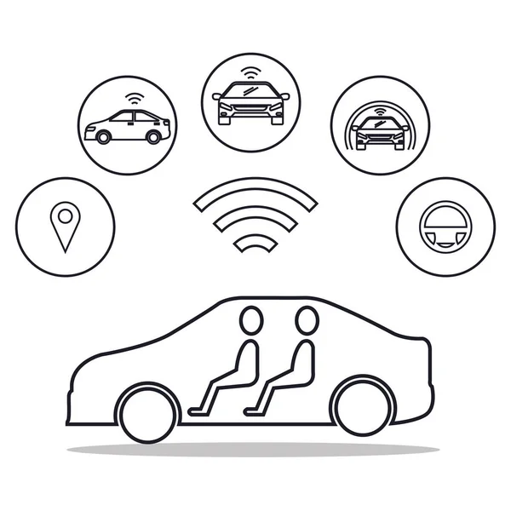

Smart Parking Refers To The Use Of Advanced Technologies And Innovative Solutions To Optimize The Process Of Finding, Reserving And Paying For Parking Spaces. As Urban Areas Continue To Grow, The Demand For Parking Spaces Has Increased Significantly, Leading To Traffic Congestion ,Environmental Pollution And Over All Inefficiency In Urban Transportation Systems. Smart Parking Systems Aim To Address These Challenges By Leveraging Various Technologies To Make Parking Easier, Faster And More Convenient For Both Drivers And Parking Facility Operators.

**Block diagram :**

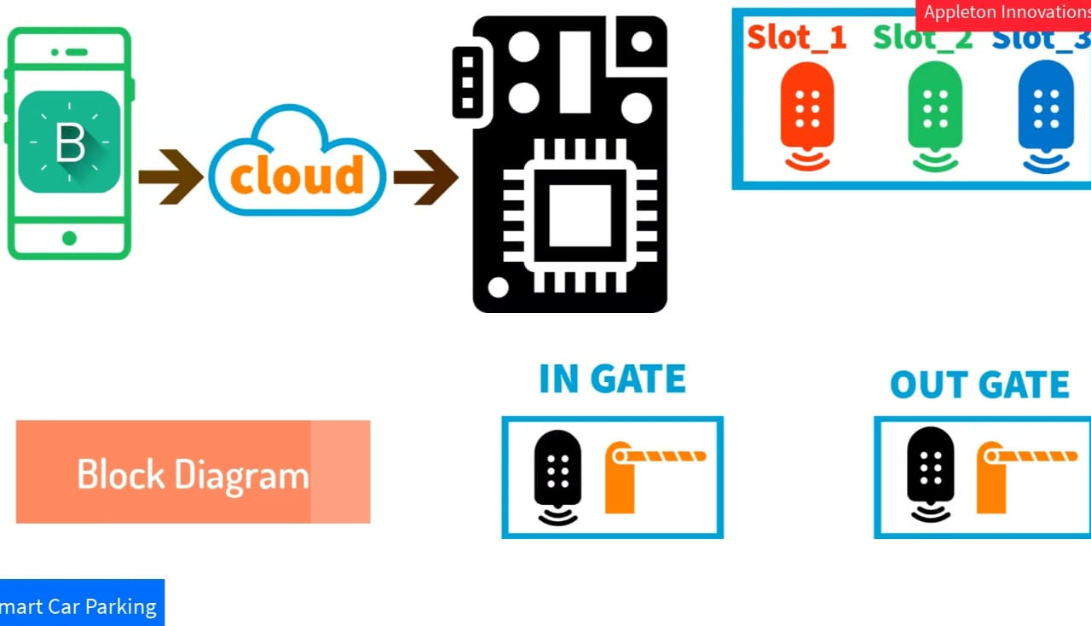

**Hardware requirements:**

**Building and development of project:**

**Components required:**

1. **Bread board**

1. **IR sensor**

1. **Lcd Display**

1. **Node MCU**

1. **Servo motor**

1. **Connecting wires and USB cable**

**Placing components on the board:**

**Initial stage**

Take all the components for connecting in the bread board to build our project

1. **First , place the Node MCU**

1. **Place the sensors on the board**

1. **Now ,connect the wires to the corresponding components**

1. **Finally , everything connected successfully**

**Connecting NODE MCU to laptop using USB**

**Now the code is debugged into our Arduino using Arduino ide 1.8.13 software**

**Coding used …….**

#define BLYNK_PRINT Serial

#include <ESP8266WiFi.h>

#include <BlynkSimpleEsp8266.h>

#include <Servo.h>

Servo servo;

Servo servo1;char auth[] = "NvvkkwRRSxhj8LPECPSY35qRgBK1UCEN";

char ssid[] = "APPLETON";

char pass[] = "Gladys@123";

const int gateInIR = D2;

const int gateOutIR = D1;

const int slotoneIR = D4;

const int slotTwoIR = D5;

const int slotThreeIR = D3;

int total = 0;

int IR1 = 1;

int IR2 = 1;

int IR3 = 1;

BlynkTimer timer:

WidgetLCD lcd (V1);

void setup() {

Serial.begin(9600) I

Blynk.begin (auth, ssid, pass);

pinMode (gateInIR, INPUT);

pinMode (gateOutIR, INPUT);

pinMode(slotoneIR, INPUT);

pinMode (slotTwoIR, INPUT);

pinMode(slotThreeIR, INPUT);

servo.attach (D7);

servol.attach (D8);

timer.setInterval (10000L, carParking);

**FINAL OUTPUT:**

* We made this simple parking system only for 3 cars to be parked.

Here ,initially 3 Slots available which denotes space for parking

A= AVAILABLE

NA=NOT AVAILABLE

Assume each sensor carrying a parking space.

**OUTPUT AFTER SOME TESTING:**

**when the car reaches the sensor 3 which is slot C. Now we got an display**

TOTAL SLOTS AVAILABLE :2

SLOT 3 : NA

**when 2 cars came , Our output will be….**

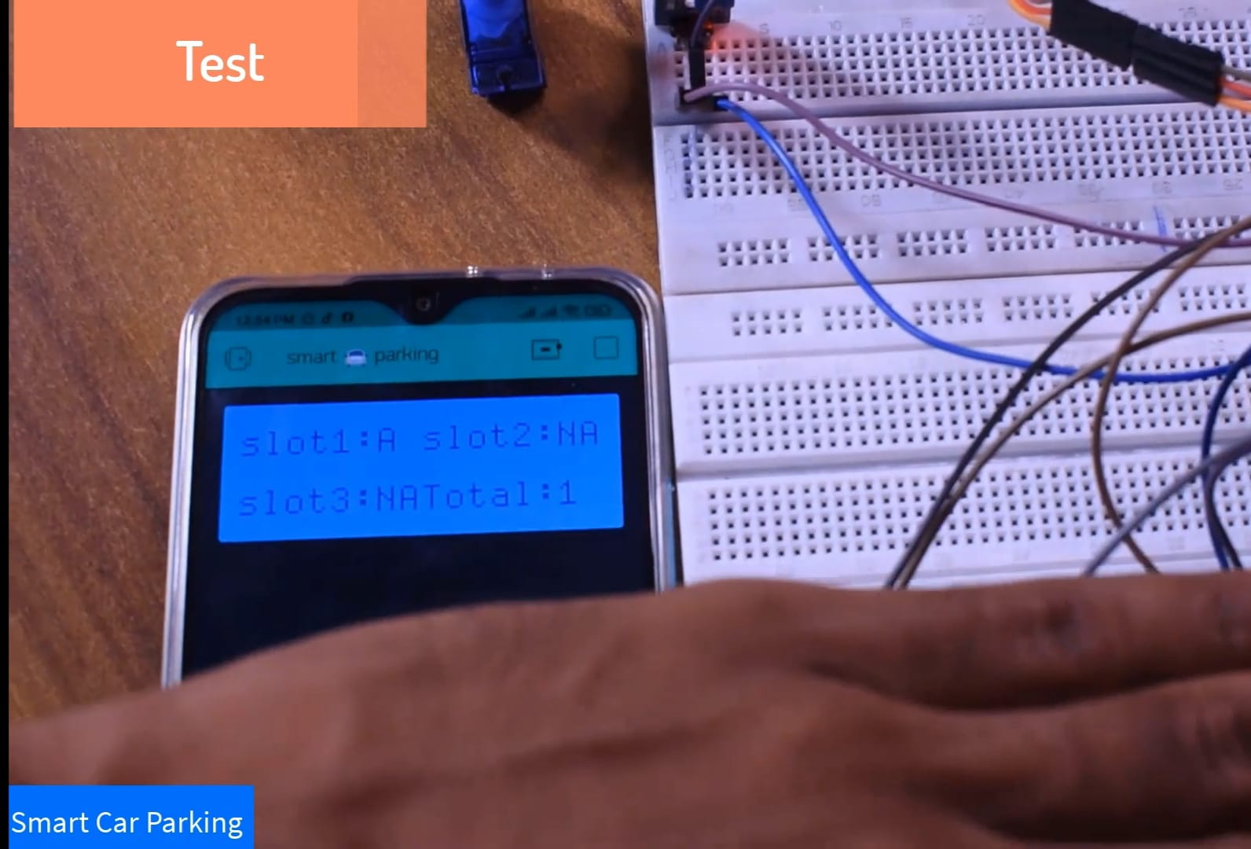

**when 3 cars came , Our output will be….**

**Need for smart parking:**

**SPECIFICATIONS :**

* Servo motor is provided for automatic gate opening and closing purpose.

* Sensors are provided for sensing the parking space availability in parking lots and also for sensing cars in gate terminals.

* lcd display is provided for displaying the parking space availability

* Mobile applications are provided for checking the parking space availability from anywhere at anytime.

* Screenshot when parking space is full

**Advantages of smart parking system :**

* Optimized parking.
* Reduced traffic.
* Reduced pollution.
* Enhanced User Experience.
* Integrated Payments and POS.
* Increased Safety.
* Real-Time Data and Trend Insight.
* Decreased Management Costs.

**Final project:**

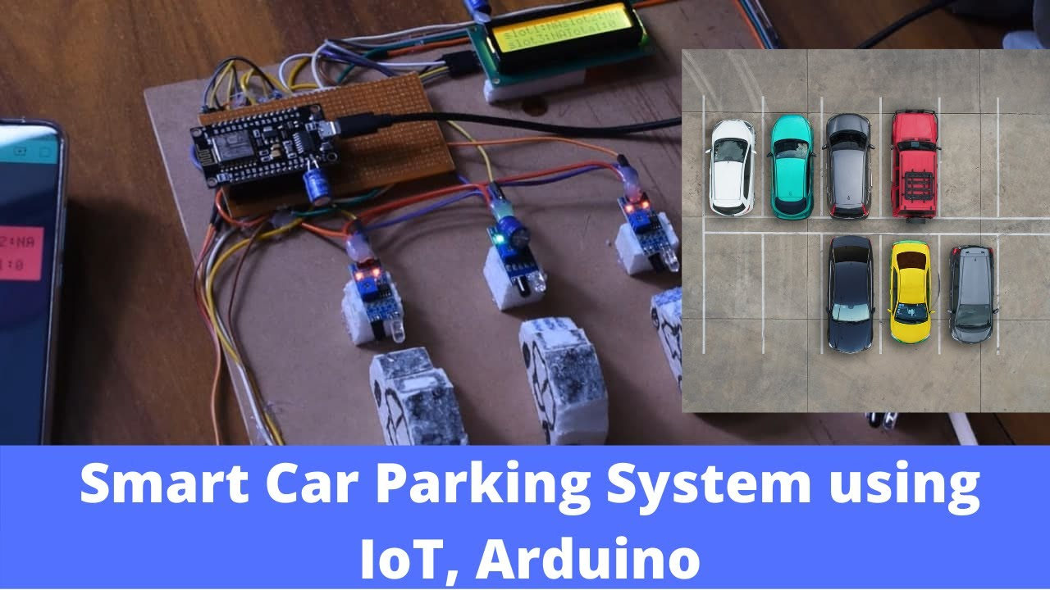

**Conclusion:**

By integrating these modules, the Smart Parking system using IoT offers a comprehensive solution to address the challenges of urban parking, leading to improved efficiency, reduced environmental impact, and enhanced user satisfaction.

**Future scope:**

Using the slot allocation method we can book our own cheapest parking slot.

